KNOWLEDGE TEST | Linux Administration  Bash Scripting
KNOWLEDGE TEST | Auteur : LCN  Service :  Date : 2019-06-15  Référence : LCN2019_06_15  N° Version :2.0

Summary
1 Linux Administration 3
1.1 Installation and securisation 3
1.2 Securised SSH Conexions 3
1.3 Filtering Policy IPTables ( Netfilter ) 6
1.4 Apache Installation 8
2 Bash scripting 12
2.1 Catch and display IP address 12

Linux Administration

Installation and securisation
Pre-requisit : Fresh Virtual Machine DEBIAN 9.9 Core installed , openssh service installed, standard repository configured .
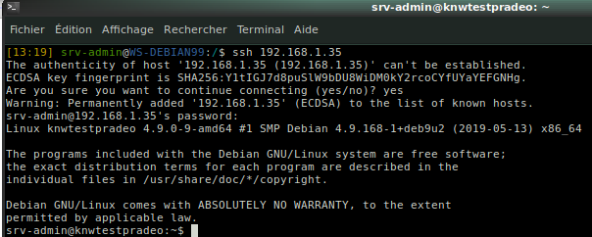

Securised SSH Conexions
Once connected to the Server , we will define a strong password to root , create a user with administrative right to be able to permanently disable ssh connexions as root.
Then we will generate private ( and public ? ) keys the administrator of this server will use to connect to without typing his password ( in case somebody take a look over his shoulder ).
When done we will include the administrator to the sudo user’s group to be able to do admin tasks.
At the end we will disable root loging from SSH .

- SSH connexion to the serveur as srv-admin and modify root password as :!D0B3RM@N3A !

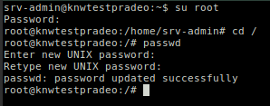
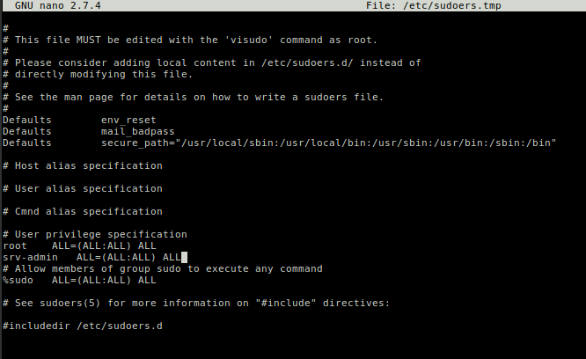
- Allow sudo for user srv-admin with visudo :
By default and only during Installation of the server , I decided to allow srv-admin for ALL commands on ALL hosts as ALL users into ALL groups in sudo config.

srv-admin ALL=(ALL:ALL) ALL

- to allow ssh connexion of user srv-admin with RSA keys , we will generate them from this serveur.
ssh-keygen
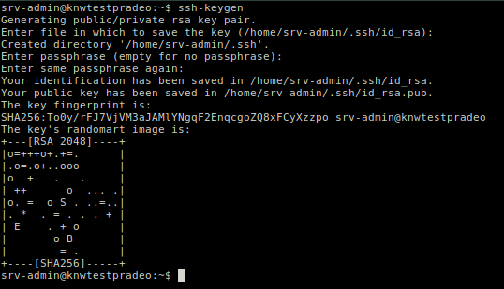
We have to register these keys to the authorized ones to permit connexions to this server.
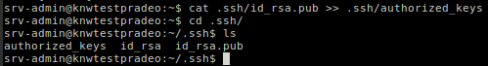
The key is located in /home/srv-admin/.ssh/id_rsa and will be installed on the workstation of the server administrator. This process can be automatized when we works with LDAP for exemple , as soon as an Admin user is intended to work on this server , his own RSA key could be created when the user is created into the LDAP arch.
The private key is located into the home folder of srv-admin into the server :
/home/srv-admin/.ssh/id_rsa

on the administrator workstation ( laptop used for this test ) we copy the public key into its own .ssh folder

test : connexion without key from a laptop

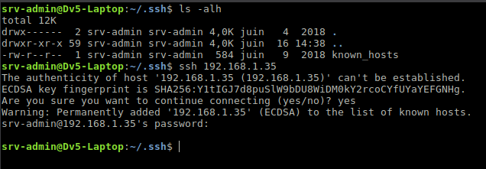

test : connexion with key
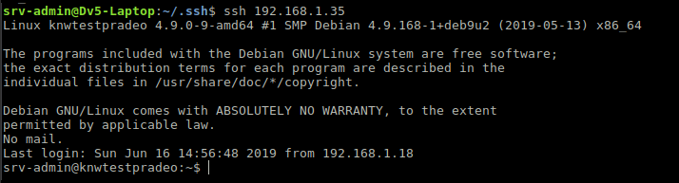

In this state , we can disable the root connexion via SSH , as the admin sys « srv-admin » is allowed to do admin tasks, and is able to connect to this server .

SSH service tweaking :

in order to close one of the sensable door , we will disable the root login via SSH , and just allow srv-admin connexion to this server.

I edit the SSH service config file to adjust parameters :
( in order to roll back in case of failure , I clone the config file : cp /etc/ssh/sshd_config /home/srv-admin/sshd_config.origin)

AllowUsers srv-admin # mandatory
PermitRootLogin no # this will disable root login
RSAAuthentication yes # this will ask for RSA key exchange during authentication
PubkeyAuthentication yes # this will use Public key for authentication
ChallengeResponseAuthentication no # not used here
PasswordAuthentication no # this will disable password authenciation , this means that no other users than all of them registered in the authorized list ( AllowUsers parameter ) will be able to connect to this server
AuthorizedKeysFile %h/.ssh/authorized_keys # indicate the path to the keys generated for the connexion to this server.

After saving this config file we have to restart sshd services :

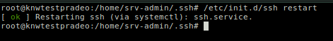
test : connecting from a worstation without key
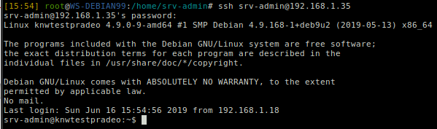
the server ask for a password as the key isn’t present AND the user can login as he is authorized by the config

test : after creating a dummy user with no right and no key trying to connecte
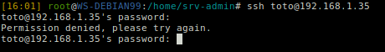
even if we type the right password AND the user is registered on the server , no connection could be done.

Test : root connexion attempt
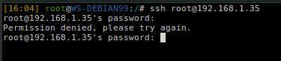
root user cannot login via SSH on the server too .

Filtering Policy IPTables ( Netfilter )
As we only need to use HTTP / HTTPS and SSH on this server , I decided to let only these trhee ports open , but hidden from outside eyes.I will use Iptables to setup Netfilter as follow :

Firstly I check the default rules as root :
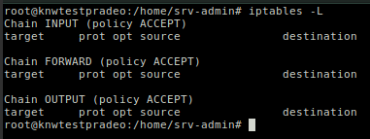
As the server isn’t made as software router , we don’t need to explore all the other rules ( pre-routing post-routing ).
to make the rules persistent I use iptables-persistent instead of reloading IP tables at boot from a backup file , because I had some weird result like rules not loaded and netfilter service entering degraded mode.

From standard repository I install the package iptables-persistent to keep theses rules in place after reboot.

apt install iptables-persistent

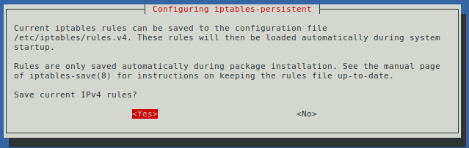
I set the rules as follow with a script , to make it easy to serialize installation or deployment

#!/bin/bash +x

# First rules for fresh install 2018 / DEB9

ip=/sbin/iptables
tcpservices="80 443 22"
udpservices=""
SERVER_IP=$(ip addr | grep 'state UP' -A2 | tail -n1 | awk '{print $2}' | cut -f1 -d'/')

# Firewall script for servername

echo -n ">> Applying iptables rules... for server at $SERVER_IP"

## flushing...
$ip -F
$ip -X
$ip -Z
$ip -t nat -F

# default: DROP!
$ip -P INPUT DROP
$ip -P OUTPUT DROP
$ip -P FORWARD DROP

# filtering...

# localhost
# $ip -A INPUT -i lo -j ACCEPT
# $ip -A OUTPUT -o lo -j ACCEPT

# allowed services
for service in $tcpservices ; do
$ip -A INPUT -p tcp -m tcp --dport $service -j ACCEPT
$ip -A OUTPUT -p tcp -m tcp --sport $service -m state --state RELATED,ESTABLISHED -j ACCEPT
done
for service in $udpservices ; do
$ip -A INPUT -p udp -m udp --dport $service -j ACCEPT
$ip -A OUTPUT -p udp -m udp --sport $service -m state --state RELATED,ESTABLISHED -j ACCEPT
done

# a server isn't intended to browse the internet
# but if needed , uncomment these rules
# $ip -A INPUT -p tcp -m tcp --sport 80 -m state --state RELATED,ESTABLISHED -j ACCEPT
# $ip -A OUTPUT -p tcp -m tcp --dport 80 -j ACCEPT
# $ip -A INPUT -p tcp -m tcp --sport 443 -m state --state RELATED,ESTABLISHED -j ACCEPT
# $ip -A OUTPUT -p tcp -m tcp --dport 443 -j ACCEPT
# $ip -A INPUT -p tcp -m tcp --sport 8080 -m state --state RELATED,ESTABLISHED -j ACCEPT
# $ip -A OUTPUT -p tcp -m tcp --dport 8080 -j ACCEPT

# For DNS request
$ip -A INPUT -p udp -m udp --sport 53 -j ACCEPT
$ip -A OUTPUT -p udp -m udp --dport 53 -j ACCEPT
$ip -A INPUT -p tcp -m tcp --sport 53 -j ACCEPT
$ip -A OUTPUT -p tcp -m tcp --dport 53 -j ACCEPT

# Keep the clock at time NTP
$ip -A INPUT -p udp -m udp --dport 123 -j ACCEPT
$ip -A OUTPUT -p udp -m udp --sport 123 -j ACCEPT

# outgoing SMTP , these rules have to be uncommented if
# mail service is needed
# $ip -A INPUT -p tcp -m tcp --sport 25 -j ACCEPT
# $ip -A OUTPUT -p tcp -m tcp --dport 25 -j ACCEPT

# allowing ICM ( ping ) From and To , to be commented
$ip -A OUTPUT -p icmp --icmp-type 8 -d 0/0 -m state --state NEW,ESTABLISHED,RELATED -j ACCEPT
$ip -A INPUT -p icmp --icmp-type 0 -s 0/0 -m state --state ESTABLISHED,RELATED -j ACCEPT

echo " OK. Check rules with iptables -L -n"

# end :)

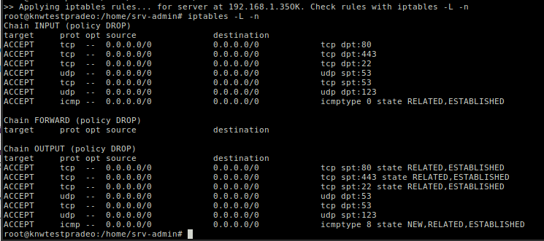
When done I save the rules so they will be loaded at startup

# iptables-save > /etc/iptables/rules.v4

and if needed for IPV6

# ip6tables-save > /etc/iptables/rules.v6

Apache Installation
From DEBIAN offical repo :

starting with default => apt install apache2

When done I check it
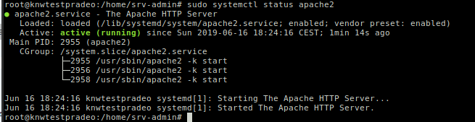
and from another station on the network :

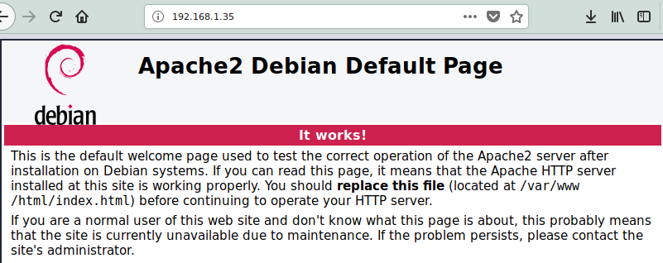
to be able to access securely this web server , we need to be trusted by the internet policy with SSL certificate , to prove that this server is secured.
This method need to be registered by a Certificate Authority , this can be done with such company like Ghandi, Thawte and many more , the process need a simple form to generate the request to obtain a signed certificate from the choosen authority.

But we can produce a self-signed certificate for test purpose for our application , and as soon as the server is going to be in production mode there is time to buy certificate from authority.

I use these steps to generate the SSL certificat but the browser detect that the certicat is self-signed and advise the user of that fact.

The commands to generate the certificate
First, we generate a private key with the following command:

openssl genrsa -des3 -out server.key 1024

We are asked to enter a password for the key and verify the password (ensure the password is strong and do not forget it). Now, generate the Certificate Signing Request with the command:

openssl req -new -key server.key -out server.csr

At this point, we are asked a number of self-explanatory questions (Country, State, City, etc.).
The key we generated has a password that has to be removed. If we do not remove this password, Apache will not be able to start without prompting for said password to be entered.

To remove the password, issue the following two commands:

cp server.key server.key.org

openssl rsa -in server.key.org -out server.key

Generate the certificate :

openssl x509 -req -days 365 -in server.csr -signkey server.key -out server.crt

The above command will generate a certificate that is valid for 365 days. We have to remember to generate a new certificate in one year.

The final step is to copy the files. The following commands will do the trick:

mkdir /etc/apache2/ssl
cp server.crt /etc/apache2/ssl/server.crt
cp server.key /etc/apache2/ssl/server.key

Configure Apache2 to use the certificates
We must ensure that Apache2 is using mod_ssl.so. To do this, issue the command:

sudo a2enmod ssl

We will be asked to restart Apache. Issue the command sudo service apache2 restart.

Now we must create a symbolic link for the default-ssl file with this command (which is one line):

sudo ln -s /etc/apache2/sites-available/default-ssl.conf /etc/apache2/sites-enabled/000-default-ssl.conf

The next step is to edit the 000-default-ssl.conf file we just created. We open the file /etc/apache2/sites-enabled/000-default-ssl.conf. Look for the following lines:

SSLCertificateFile /etc/ssl/certs/ssl-cert-snakeoil.pem
SSLCertificateKeyFile /etc/ssl/private/ssl-cert-snakeoil.key

And change them to:

SSLCertificateFile /etc/apache2/ssl/server.crt
SSLCertificateKeyFile /etc/apache2/ssl/server.key

Where we copied the certs before

Restarting Apache, and we should immediately be greeted by a « Connection is not secure » error; this happens because your browser will report that Apache is using a self-signed certificate. It is okay to add an exception for your browser so the certificate will be accepted.

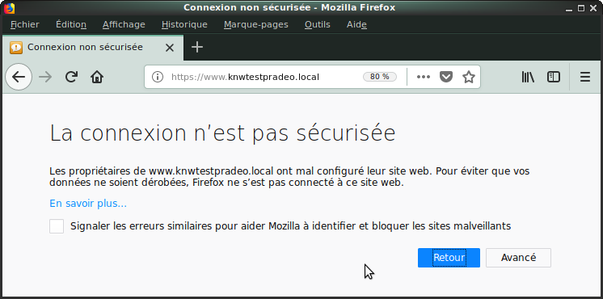

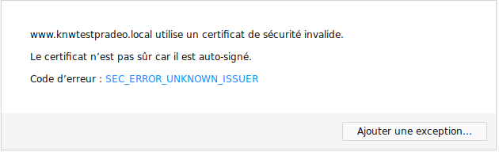

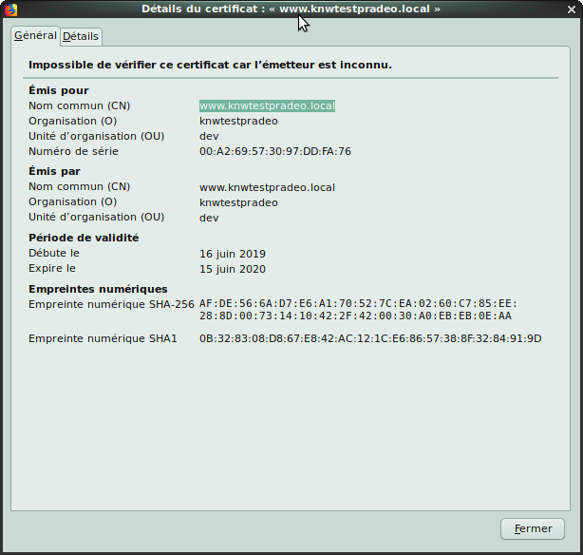
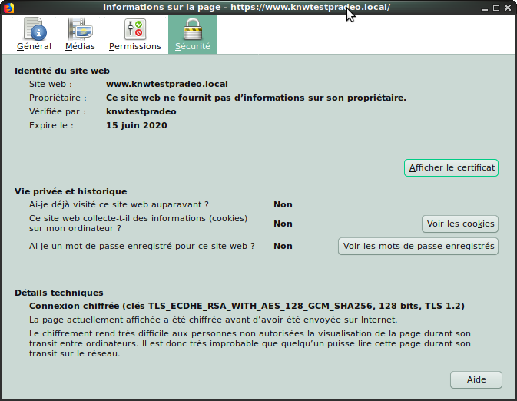

Now we want that all HTTP trafic on port 80 will be redirected to HTTPS port 443, this can be achieved follwing different ways :

- Enable the redirect in the Virtual Host file for the necessary domain.
- Enable it in the .htaccess file (previously created in the web root folder).
- Use the mod_rewrite rule in the Virtual Host file ( need a2enmod mod_rewrite ).
- Use it in the .htaccess file to force HTTPS.

To be close to the general config purpose ( means various linux distribution ), I decided to enable the redirection via virtual host configuration , because the easiest way to make it simple , as at this state we dont know if all the web site have to be redirected , or just some of the page , like payment zone , or only where a critical form have to be secured for example .

My config file is like this :

<VirtualHost *:80>
ServerName www.knwtestpradeo.local
ServerAdmin webmaster@localhost
DocumentRoot /var/www/html
ErrorLog ${APACHE_LOG_DIR}/error.log
CustomLog ${APACHE_LOG_DIR}/access.log combined
</VirtualHost>

Back it up in case of failure : cp /etc/apache2/sites-enable/000-default.conf /backedconf/apache2/ 000-default.conf.origin

I just have to tweak this config file like this :

<VirtualHost *:80>
ServerName www.knwtestpradeo.local
Redirect permanent / https://www.knwtestpradeo.local/
</VirtualHost>

After apache service restarted , every request on HTTP is redirected on HTTPS on the same server .

Bash scripting

Catch and display IP address

Script writing to display all the IP adresses the computer is using , all private address will be displayed in Green and all public addresses will be displayed in Red.
The goal isn’t only to display colored text , but catch and treat the IP address to know the kind of IP address with the fact that the computer could have more than one IP address on the same interface

in all classes of Ip address we have a private range in these class ( A B C ), I think that is a good choice to catch all IP address the machine use and translate it (or them ) in decimal and compare the result and the range of private IP address , if the result is in the range we display it in green , if not it wiil be displayed in red .

Private IP are :

- class A : 10.0.0.0 to 10.255.255.255 | 167772160 to 184549375
- class B : 172.16.0.0 to 172.31.255.255 | 2886729728 to 2887778303
- class C : 192.168.1.0 to 192.168.255.255 | 3232235776 to 3232301055

I check the ip address :

ip addr | grep 'state UP' -A2 | tail -n1 | awk '{print $2}' | cut -f1 -d'/'

I can put it into a var :

getipz=$(ip addr | grep 'state UP' -A2 | tail -n1 | awk '{print $2}' | cut -f1 -d'/')

to translate the IP address I can use this it’s not my own source but I use it for a While
ip2dec () {
local a b c d ip=$@
IFS=. read -r a b c d <<< "$getipz" <= IP in a var
printf '%d\n' "$((a * 256 ** 3 + b * 256 ** 2 + c * 256 + d))"
}

Trying the script :

#!/bin/bash

getipz=$(ip addr | grep 'state UP' -A2 | tail -n1 | awk '{print $2}' | cut -f1 -d'/')
ip2dec () {
local a b c d ip=$@
IFS=. read -r a b c d <<< "$getipz"
printf '%d\n' "$((a * 256 ** 3 + b * 256 ** 2 + c * 256 + d))"
}

rezult=$(ip2dec "$@")
#debug echo $rezult

if [ $rezult -gt 3232235776 ] && [ $rezult -lt 3232301055 ]
then
echo "PRIVATE"
/bin/echo -e "\e[1;32m$getipz\e[0m"
else
echo "PUBLIC"
/bin/echo -e "\e[1;31m$getipz\e[0m"
fi

and get the result :

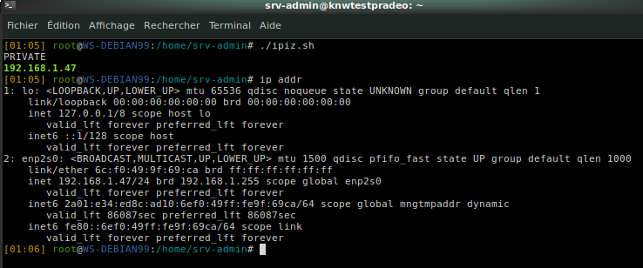

This works with only one IP address , but in the case of multiple IP address , we have to treat all the occurence ( IP Address ), with the same test , this can be done with this script :

#!/bin/bash

## - If we only want the State UP interfaces we uncomment the following line
# getipz=$(ip addr | grep 'state UP' -A2 | tail -n1 | awk '{print $2}' | cut -f1 -d'/')

## - If we only want All interfaces we uncomment the following line
# getipz=$(ip addr | grep 'inet' | awk '{print $2}' | cut -f1 -d'/')

## - This line is only for debugging
getipz="78.216.202.209 192.168.1.35 127.0.0.1"

## - here is the fonction to convert all digit of the IP Address into Decimal
ip2dec () {
local a b c d ip=$@
IFS=. read -r a b c d <<< "$count"
printf '%d\n' "$((a * 256 ** 3 + b * 256 ** 2 + c * 256 + d))"
}

## - In order to treat EACH IP Address one by one we cut the result into X line
ipiz=$(echo $getipz | tr " " "\n")

## - We read all occurence from the result
for count in $ipiz
do

## - the following could be done with CASE ESAC statement but I decided to treat the result with condition test.

rezult=$(ip2dec "$@")
## - Is the result in the range of PRIVATE Class A IP
if [ $rezult -ge 3232235776 ] && [ $rezult -le 3232301055 ]
then
echo "PRIVATE"
/bin/echo -e "\e[1;32m$count\e[0m"
## - Is the result in the range of PRIVATE Class B IP
elif [ $rezult -ge 2886729728 ] && [ $rezult -le 2887778303 ]
then
echo "PRIVATE"
/bin/echo -e "\e[1;32m$count\e[0m"
## - Is the result in the range of PRIVATE Class A IP
elif [ $rezult -ge 167772160 ] && [ $rezult -le 184549375 ]
then
echo "PRIVATE"
/bin/echo -e "\e[1;32m$count\e[0m"
## - Addon to display if the IP is the loopback or not
elif [ $rezult -eq 2130706433 ]
then
echo "LOOPBACK"
/bin/echo -e "\e[1;32m$count\e[0m"
## - If the Result isn’t in one of the range , this means that this is a PUBLIC address
else
echo "PUBLIC"
/bin/echo -e "\e[1;31m$count\e[0m"
fi
done

